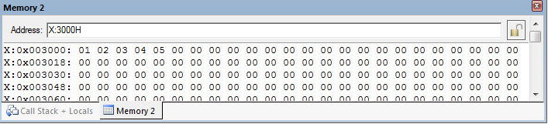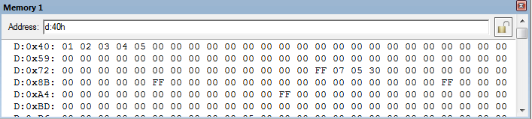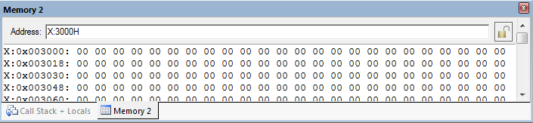

After Execution:

Output 1b:

Before Execution: